**CGG Image Validation API Implementation Details**

**config.properties**

|  |  |
| --- | --- |
| [image] - **Blurriness threshold** | blurness_threshold_start=0  blurness_threshold_end=2  brightness_threshold=220 |
| [fullscan] – **Full scan threshold** | fullscan_start=89  fullscan_end=100  fullscan_sign_start=99  fullscan_sign_end=100 |

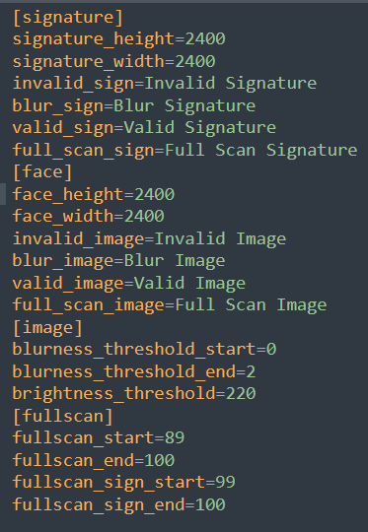

**Blur Detection (face / signature):**

A function is said to be a piecewise continuous function if it has a finite number of breaks and it does not blow up to infinity anywhere. Let us assume that the function f(t) is a piecewise continuous function, then f(t) is defined using the Laplace transform. The Laplace transform of a function is represented by L{f(t)} or F(s). Laplace transform helps to solve the differential equations, where it reduces the differential equation into an algebraic problem. It is the integral transform of the given derivative function with real variable t to convert into a complex function with variable s. For t ≥ 0, let f(t) be given and assume the function satisfies certain conditions to be stated later on.

Using open-cv we can calculate Laplace transform as mentioned below.

# Blur detection with OpenCV

score = cv2.Laplacian(image, cv2.CV_64F).var()

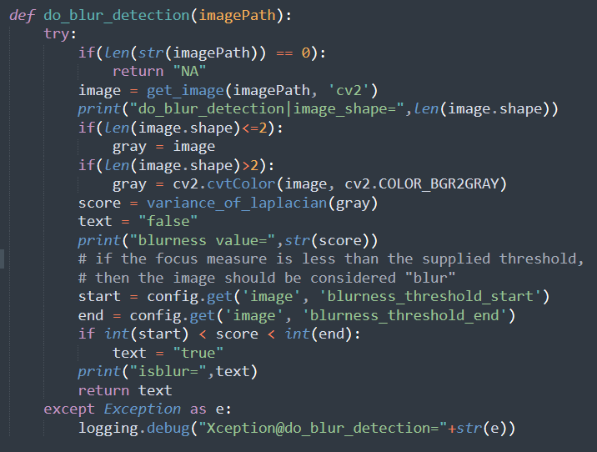

If the focus measure of the image falls within the certain threshold(blurness_threshold_start < score <blurness_threshold_end) as mentioned in the above properties, then image is considered as blurry.

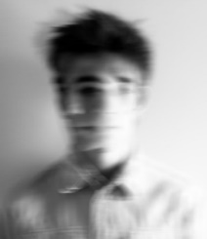 

Fig 1. Blurry Fig 2. Non-Blurry

Images with high brightness / contrast also categorized as blurry. If the brightness measure is greater than or equal to 220 then that image also considered as blurry.

**Brightness detection (face / signature):**

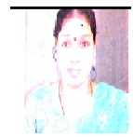

Fig 3. High brightness image

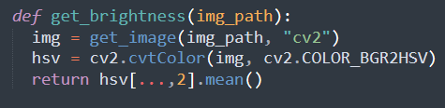

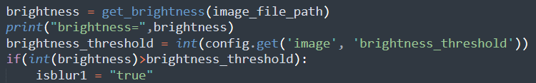

**Explanation – Fig 3**

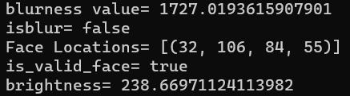

Blurriness value of Fig 3 is 1727 which is not blurry and brightness is 238, as the brightness value is above 238 > brightness_threshold=220 and is categorized as blurry.

Note if image is blurry face detection will not happen.

**Full Scan Image Detection (face / signature):**

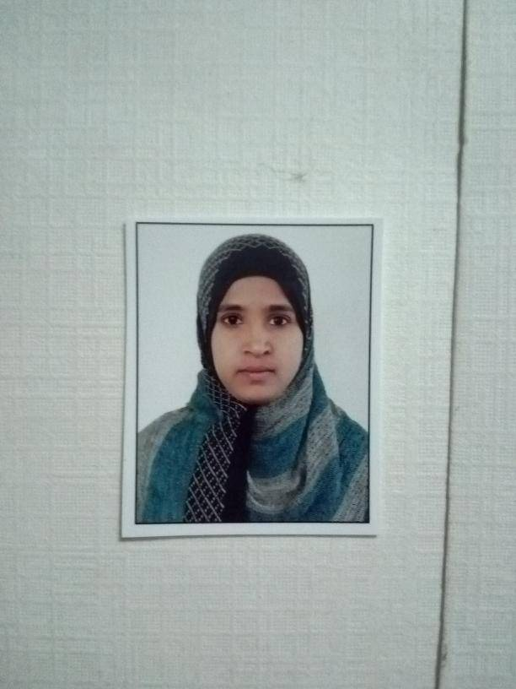 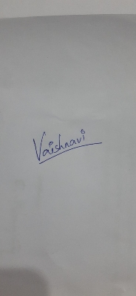

Fig 4. Full scan images sample

**Explanation:**

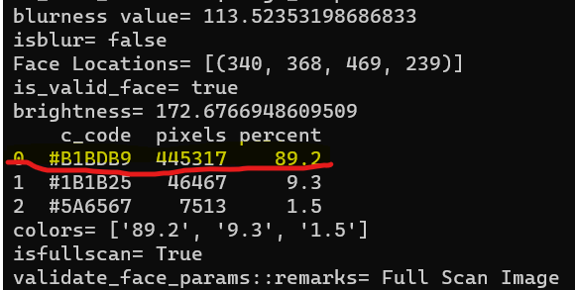

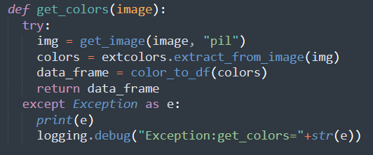

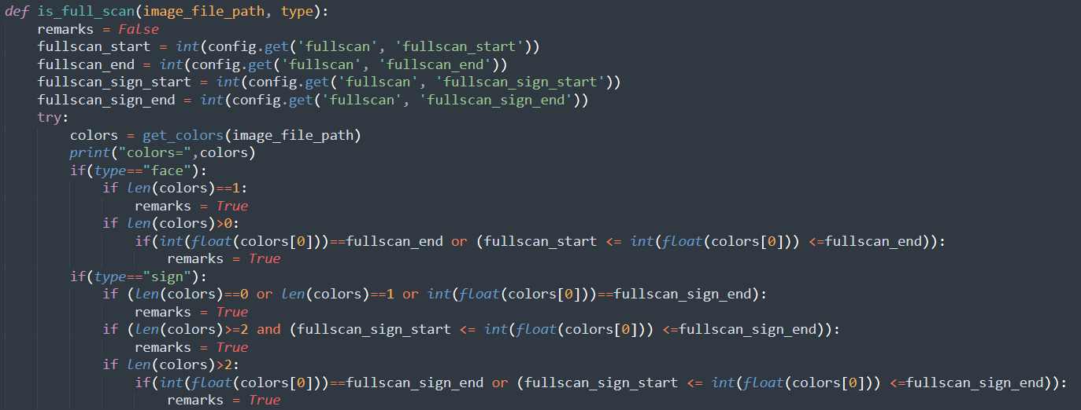

Full scan detection is made by applying color segmentation and sorting all the available colors in the image, if any color in the image is between 89%-100% then that image is considered as full scan image as per above result.

**Face Detection:**

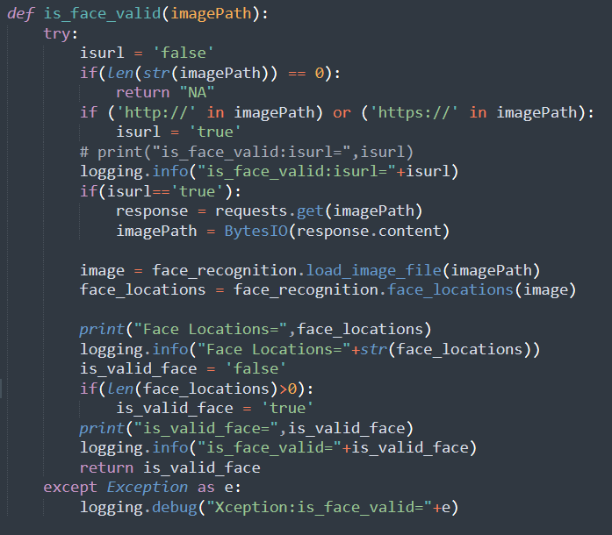

**Validation of face params:**

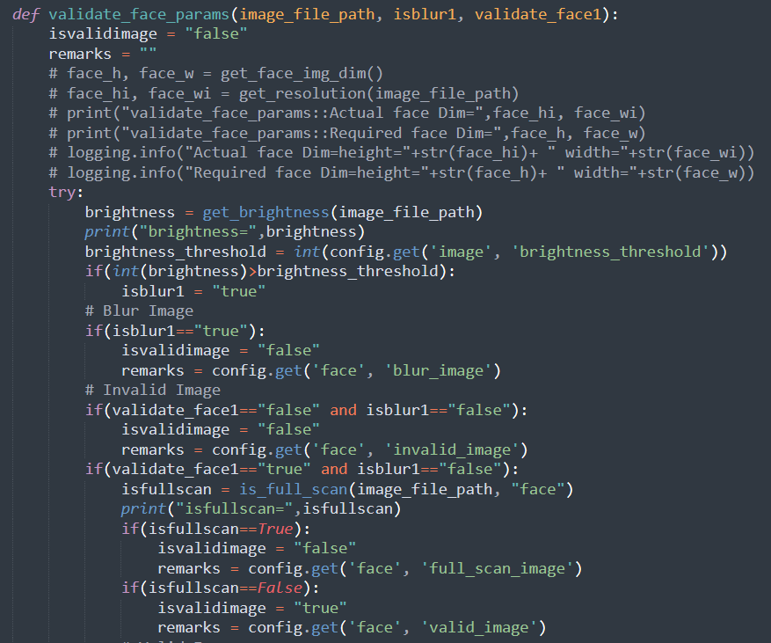

**Signature Detection:**

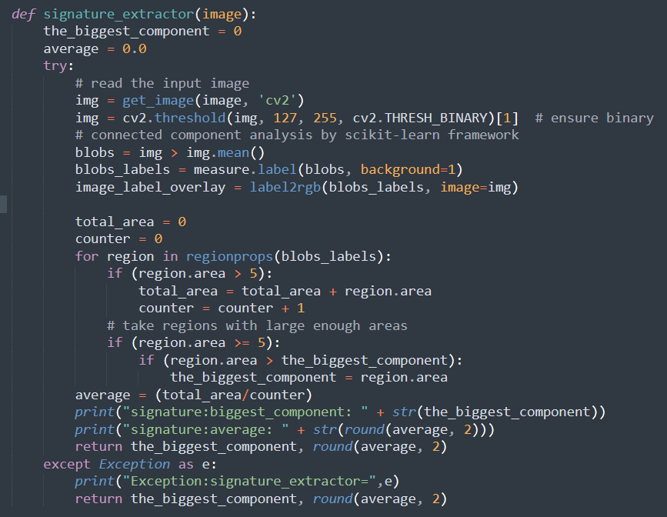

**Validation of signature params.**

